CHURCH VIEW SURGERY
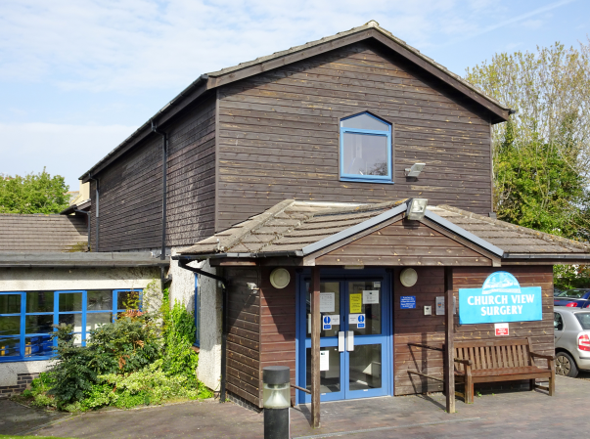
CHURCH VIEW SURGERY
New Patient – Registration Pack
Child 0 – 16 years

Welcome to Church View Surgery.

Please complete the attached Registration Paperwork in full and ensure that you provide the following information as without it your full registration at this practice will not be able to proceed / may be delayed:

- Your Red Immunisation Book, which will provide us with your NHS number.

- Your Birth Certificate.

Communication Needs
Language | What is your main spoken language?  Do you need and interpreter? Yes No
Communication | Do you have any communication difficulties? Yes No  If Yes please identify below
 | Hearing aid  Lip reading | Large print  Braille | British Sign Language  Makaton Sign Language Guide dog

PATIENTS NAME:....................................................................................
Receptionist check registration details: .....................................................
ID Checked was/is:.......................................................................................

NEW PATIENT REGISTRATION/HEALTH QUESTIONNAIRE

To All New Patients,
A Very Warm Welcome to Church View Surgery

This questionnaire can be used to capture data for new patient registrations and will also help to establish a base-line view of your lifestyle and will assist the nurse / doctor in carrying out a new patient health check. The information that you provide will assist also in identifying patients who may be at risk of developing any chronic disease.

Copies of our Patients’ Charter, Patient Information Leaflet and Complaints Procedure are available on request.

NEW PATIENT REGISTRATION/HEALTH QUESTIONNAIRE
By completing this form you are consenting to Church View Surgery using these details to contact you by whichever means is appropriate:

Surname: …………………………………………………. Forename(s): ……………………………………………….…………

Previous Surname………………………………………

Date of Birth: …………………………………………….. Marital status: ….………………………………………….…………

Address: ………………………………………………………………………………………………………………………………………………..….

…………………………………………………………………… Postcode: ……………………………………………..……………..…

Home Tel: ……………………………………………..……

Mobile: …………………………………………….………………….…
I consent to be contacted by SMS on this number please tick

Email address: …………………………………………………………………………………………………………………………….……………
I consent to be contacted by Email at this address please tick

It is your responsibility to keep us updated with any changes to your telephone number, email and postal address. We may contact you with appointment details, test results, health campaigns.
If you do not consent to being contacted by SMS or Email, please tick here: SMS Email

Occupation: …………………………………………………………………………………………………………………………………………….

Weight (Approx): ……………………………………….. Height: …………………………………………

Contact in case of Emergency;

Name:......................................... Address:......................................................

Tele No:..................................... Relationship:................................................

Date of completion of this form: ………………………………………………………………………….

FAMILY HISTORY

Is there any of the following in your family (father, mother, brother, sister) before age of 65?

Heart Disease (heart attacks, angina) Yes / No which family member? ………………………….

Stroke? Yes / No which family member? ………………………….

Cancer? Yes / No which family member? ………………………….

Site of cancer? ……………………………………….……………
MEDICATION
Please give details of any medication which you take (prescribed or otherwise), and attach a copy of a repeat prescription if you have one:
MEDICATION

If you would like to register for Online Services for Prescription Requests, please include your email address below and we will send you your secure login details

Email Address: ………………………………………………………………………………………

NOMINATED PHARMACY: ………………………………………………………………………….
(By nominating a Pharmacy your prescription will be automatically sent to them via our Electronic Prescription Service)
Name of drug: ……………………………………
Dosage: …………………………………………….

Name of drug: ……………………………………
Dosage: …………………………………………….

Name of drug: ……………………………………
Dosage: …………………………………………….

Name of drug: ……………………………………
Dosage: …………………………………………….

Name of drug: ……………………………………
Dosage: …………………………………………….

Name of drug: ……………………………………
Dosage: …………………………………………….

Name of drug: ……………………………………
Dosage: …………………………………………….

Name of drug: ……………………………………
Dosage: …………………………………………….

Name of drug: ……………………………………
Dosage: …………………………………………….

Please continue on a blank page if necessary
ALLERGIES
Are you allergic to any substances or foods? Yes / No

If yes, please give details: ………………………………………………………………………………….............................................................................................................................................................................................................................................................................................................................................................................

PAST MEDICAL HISTORY

Please give details of any treatment for any significant medical conditions: e.g. Diabetes, asthma, epilepsy, high blood pressure.
Please continue on a separate sheet if necessary.
…………………………………………………………………………………………………………………………………….......................................................................................................................................................................................................................................................................................................................................................................................................................................................................................................................................................................................................................................................................................................................................................................................................................................................................................................

Thank you for completing this questionnaire. Your doctor will assess the information provided and will invite you for an initial appointment if needed.

If you wish to consent to any of the following PLEASE TICK in the relevant box

Patient Name………………..……………..……………….. DOB………………..….… Signature………………….…………………
Children Under the age of 16 will automatically have a summary care record created for them unless their GP surgery is advised otherwise.
Please tick as required
Summary Care Record:

This is a summary of your Medical, Allergies & Adverse Reactions & can only be accessed by a Clinician in England & with your expressed consent. This will help with your care.

Website is – http://systems.hscic.gov.uk/scr/patients
Summary Care Record with Additional Information:

What is additional Information?
Additional information can be added to your SCR by your GP practice and is a summary of information about your medical history. It can include the following:

Your long term health conditions such as asthma, diabetes, heart problems or rare medical conditions.

Your relevant medical history – clinical procedures that you have had, why you need a particular medicine, the care you are currently receiving and clinical advise to support your future care.

Your healthcare needs and personal preferences – you may have particular communication needs, a long term condition that needs to be managed in a particular way, or you may have made legal decisions or have preferences about your care that you would like to be known.
ENHANCED DATA SHARING MODEL ‘SystemOne’
Sharing Out – Do you consent to the sharing of data recorded by your GP practice with other NHS organisations that may care for you?

